**Abhinav Jain**

**500083840**

**Experiment-3**

1. **Create the following table:-**

**Supplier-(scode,sname,scity,turnover)**

**Part-(pcode,weigh,color,cost,sellingprice)**

**Supplier_Part-(scode,pcode,qty)**

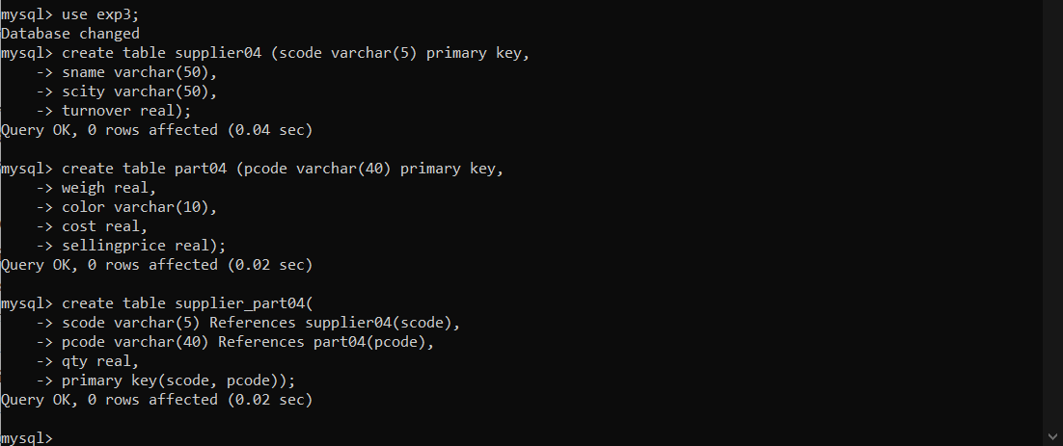

**2. Populate the table**

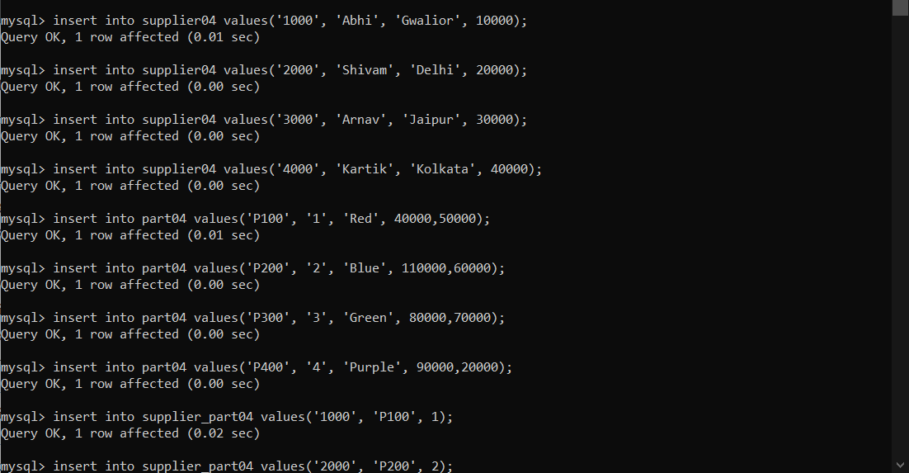

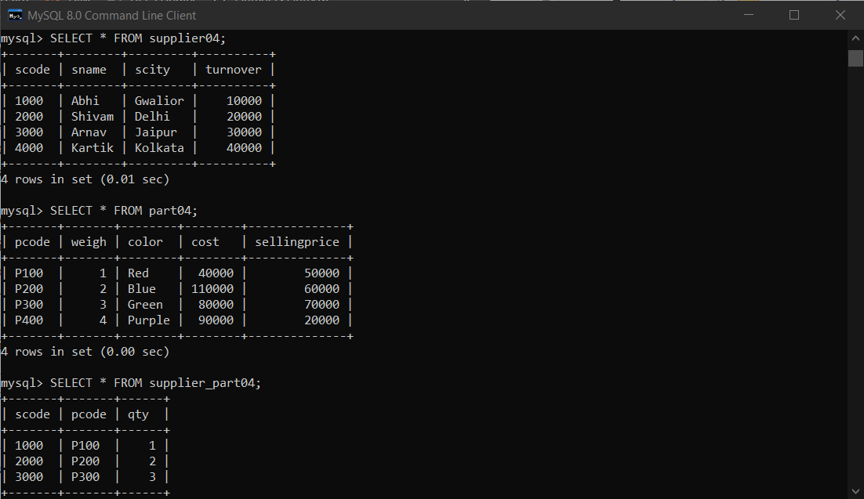

**3. Write appropriate SQL Statement for the following:**

1. Get the supplier number and part number in ascending order of supplier number

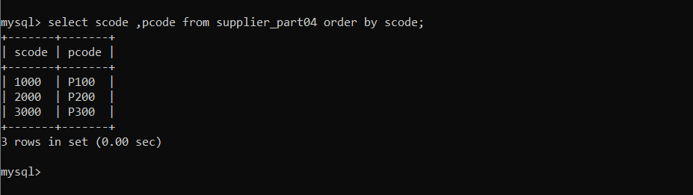

2. Get the details of supplier who operate from Bombay with turnover 50.

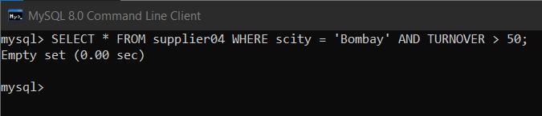

3. Get the total number of supplier.

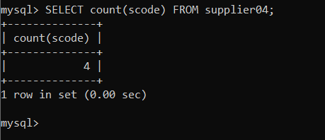

4. Get the part number weighing between 25 and 35.

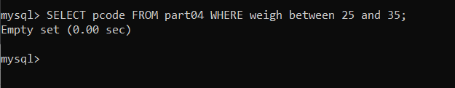

7. Get the total quantity of part 2 that is supplied.

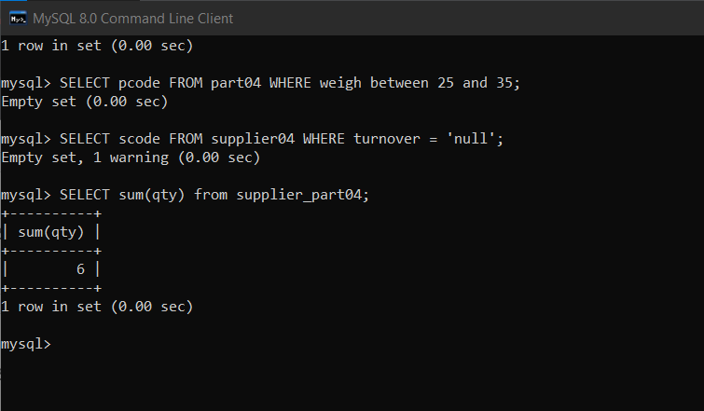

8. Get the name of supplier who supply part 2.

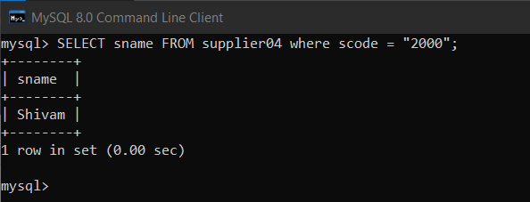

9. Get the part number whose cost is greater than the average cost.

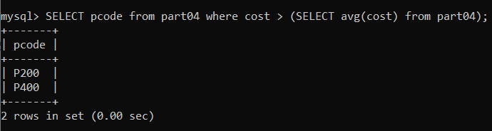

10. Get the supplier number and turnover in descending order of turnover.

